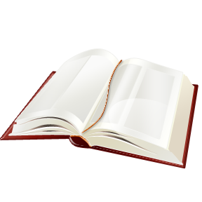
Mrs. Varela
English 11

Independent Reading Project

- Choose a non-fiction book of at least 250 pages.

- Read the book noting interesting vocabulary, the author’s style, use of literary elements, and themes.

- Write a one-page biography of the author. (must be submitted to turnitin.com)

- Write a one-page review of the book discussing use of literary elements and themes. (must be submitted to turnitin.com)
  - Typed double spaced
  - 12 pt Times New Roman font

- Write 10 higher level thinking questions for the book (5 Level 3 and 5 level 4)

- Create a ten-word glossary of new-to-you vocabulary found in the book. Entries should be placed in alphabetical order with the page number it was found on.
  - Write the dictionary definition of the word.
  - Use the word in your own sentence.

- Create an illustration or collage to represent your book.

- Place your final copy items in a report folder in the following order:

  - Title Page (including the title of the book and author, your name, class hour, and date) /5
  - Author Biography /25
  - Book Review /25
  - Higher Level Thinking Questions /10
  - Vocabulary Glossary /15
  - Illustration /20

Due: Monday, September 25th .

